Traffic Sign Detection Using YOLOv8
Author: Alperen Yanık
Abstract
This study presents the use of the YOLOv8 (You Only Look Once) object detection model for traffic sign detection. The goal is to develop a model that accurately and rapidly identifies various traffic signs. The model was trained on a dataset of 3308 images and achieved high accuracy and fast inference times. The results demonstrate that YOLOv8 is well-suited for real-time applications.
Keywords
Traffic sign detection, YOLOv8, object detection, computer vision, deep learning.

1. Introduction
Traffic sign detection is a crucial task in autonomous driving and intelligent transportation systems. In this work, the YOLOv8 model is utilized to detect traffic signs accurately. YOLOv8, known for its high speed and accuracy, is ideal for real-time applications.

2. Methodology
The dataset consists of 3308 images of traffic signs, which were augmented using techniques such as auto-orientation and resize. YOLOv8 was trained on this dataset, achieving high performance in detecting traffic signs. The model was trained for 50 epochs.

3. Results
The YOLOv8 model was trained and evaluated on a custom traffic sign dataset containing 18 different traffic sign categories. The dataset consists of traffic signs such as speed limits, stop signs, and traffic lights. The evaluation metrics used include accuracy, precision, recall, mean Average Precision (mAP) at different thresholds.
3.1. Traffic Sign Categories
The model was evaluated on the following traffic sign categories:
- 20 Speed Limit
- 30 Speed Limit
- 30 Speed Limit End
- Stop
- Bus Stop Sign
- No Entry
- Forward and Right
- Forward and Left
- Closed Road
- No Parking
- Parking Allowed
- Right Turn
- No Right Turn
- Left Turn
- No Left Turn
- Red Traffic Light
- Yellow Traffic Light
- Green Traffic Light
3.2. Evaluation Metrics
The performance of the YOLOv8 model was evaluated using the following metrics:
- Accuracy: The percentage of correctly identified traffic signs in the dataset.
- Precision: The ratio of correctly predicted positive observations to the total predicted positives.
- Recall: The ratio of correctly predicted positive observations to all observations in the actual class.
- Mean Average Precision (mAP): The mean of average precision scores at various IoU thresholds (typically at 0.5 and 0.75).
- Intersection over Union (IoU): A measure of overlap between the predicted bounding boxes and the ground truth.
3.3. Performance Results
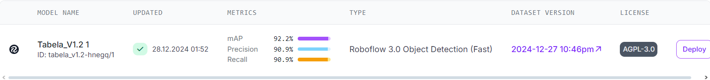
- Precision: The model achieved a precision of 90.9%, indicating that most of the predicted traffic signs were correct.
- Recall: The model achieved a recall of 90.9%, showing that it was able to identify most of the actual traffic signs in the dataset.
- mAP: The model achieved a mAP of 92.2%.
The model performed particularly well on common traffic signs like "Stop" and "Speed Limit", while slightly lower performance was observed for more complex or rare traffic sign like "No Right Turn".

4. Conclusion
YOLOv8 performs exceptionally well for traffic sign detection, offering high accuracy and fast inference times. Future work could focus on expanding the model to detect more types of traffic signs and testing its performance under challenging weather conditions.

References
[1] J. Redmon, S. Divvala, R. Girshick, and A. Farhadi, “You Only Look Once: Unified, Real-Time Object Detection,” Proc. IEEE Conf. Comput. Vis. Pattern Recognit., 2016, pp. 779–788.
[2] A. Bochkovskiy, C. Y. Wang, and H. Y. M. Liao, “YOLOv4: Optimal Speed and Accuracy of Object Detection,” arXiv preprint arXiv:2004.10934, 2020.

